S. s. SUMIDA
Biology 340
Comparative Embryology

Laboratory Exercise 3
Laboratory Examination of the Chicken Embryo
Part I

Introduction

With the use of serial cross-sections of chicken embryos, you are about to embark on one of the classic exercises in the history of animal biology. The integration of a series of two-dimensional slices of an organism into a three-dimensional understanding of that organism is at once both a review of a profound activity in comparative embryology as well as the basis of the new insights that have been afforded us by the new scanning technologies of today.

This study will be the most intensive to date in this class. It will demand integrative three-dimensional thinking and, above all, patience. If you go through the exercise with care and patience, you will be rewarded with an understanding of the relationship between embryological structures and adult structures.

Materials

Because chicken eggs are of wide availability, they are used here as the basal amniote representative in our morphological series. You will be examining both whole mounts and serial sections of 24, 33, 48, and 72 hour embryos. Please be sure that you DO NOT mix slides back and forth between different slide sets!

The whole mounts are made by removing the embryonic disc from the surface of the egg yolk and mounting it on a slide. DO NOT USE THE OIL IMMERSION LENS ON THE WHOLE MOUNT PREPARATIONS. Whole mounts are relatively thick, especially at later developmental stages and the mounting may be as much as three to four millimeters in thickness. Your oil immersion lens will not clear the mounted specimen

The Trilaminar Embryo

Recall from your lectures and previous labs that the vertebrate embryo eventually attains an organization that includes three basic layers of developmentally determined tissues: ectoderm, endoderm, and mesoderm. Remember that each of these germ layers gives rise to specific structures. The ectoderm gives rise to components of the nervous system and external structures of the skin. Endoderm gives rise to the inner lining of the gut and organs that are derived from the gut. Mesoderm gives rise to almost everything else.

The 24 Hour Chicken Embryo, Whole Mount

Notice that by 24 hours, the chicken embryo already demonstrates an axis of symmetry. That is, it has a right and left side. The head, foregut, and first somites are visible. See figure 1 or 8.30 of your lab manual

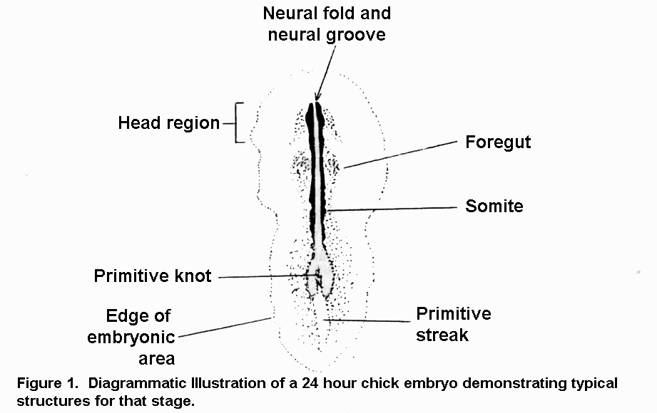

Of particular significance are the somites. Somites (mesodermal in origin) are expressed as a series of serially repeating mesodermal blocks so similar morphology. Here we have the first indication of segmentation in the chicken embryo.

In the dorsal view of the whole mount, the most obvious feature is an elongate groove running the length of the developing embryo. This is the neural groove, which will later zip up to become the dorsal hollow nerve cord. Recall from your lectures that the neural groove starts out as a thickening of surface ectoderm that eventually rolls up on itself to produce the hollow structure that will become the neural tube.

Another longitudinal structure of particular importance is the notochord. It is derived from a special type of mesoderm called chordamesoderm. It may not be quite visible at this stage, and it is often difficult to distinguish in the whole mount. Try focusing up and down to change your plane of focus as you try to find it. When visible, the notochord will be expressed as a clearly defined, longitudinal rod of cells that runs the length of the embryo just ventral to the neural tube. The relative position of the notochord, neural tube, gut tube, and the somites (and their derivatives) is a recurring theme throughout the course.

The developing gut tube is another structure that will extend most of the length of the embryo. The inner lining of the gut tube will be composed of endoderm. It will be difficult to see in the whole mount, but will become much more clearly visible when you start to examine serial sections.

Exercise 1

Using Figure 1 and images from your lab manual (8.30 and others) as a guide, observe the 24 hour chicken whole mount under various magnifications with the compound microscope. Identify the head end of the embryo. Also identify the region of the foregut. Find the neural groove and neural folds just lateral to them. Identify somites that should be visible just lateral to the neural folds near the middle of the embryo. Attempt to find the notochord.

33 Hour Chicken Embryo, Whole Mount

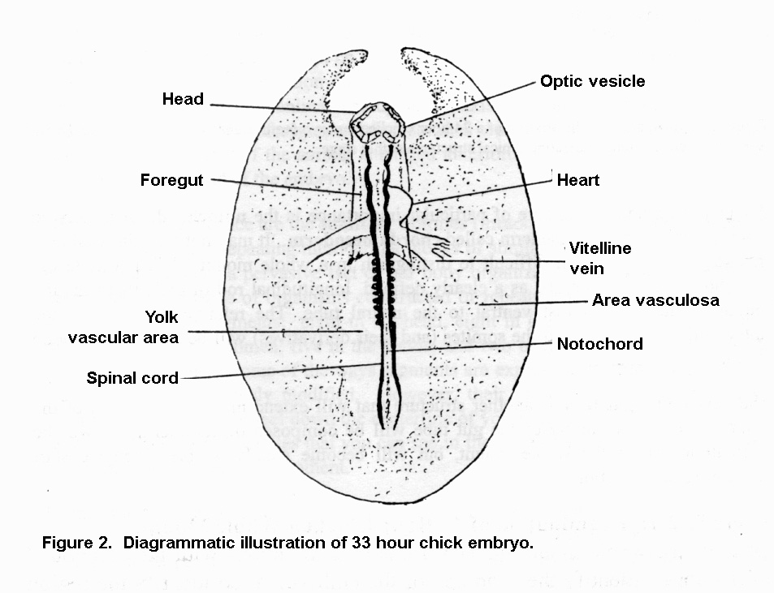
We now jump forward in the developmental sequence and examine the whole mount of a 33 hour embryo. Between 24 and 33 hours, the head elongates significantly, and the foregut is elongated concomitantly. The number of somites has increased. The neural groove has begun to close up as a true neural tube. (We won’t concern ourselves with the subdivisions of the brain just now.) The heart has begun to form at this stage, just ventral to the foregut.

Exercise 2

Using Figure 2 and images from your lab manual as a guide, observe the 33 hour chicken whole mount under various magnifications. Find the anterior enlargement of the dorsal hollow nerve cord which may now be identified as the brain. Note the limits of the head and foregut. Count the number of somites. This number may vary from slide to slide, but it should minimally be more than the number you saw in the 24 hour mount. Attempt to locate the notochord. By 33 hours, the newly developing heart has bulged out to the right.

33 Hour Chicken Embryo, Serial Sections

Some of the structures, while visible in the whole mount, can be much more clearly understood in terms of their three-dimensional placement if observed in a series of sections of an organism. As mentioned in the introduction of this laboratory exercise, you are about to embark on a classical zoological exercise – the understanding of the topology of an organism from a series of two-dimensional serial sections. What is critically important is that you take the time to scan through a number of sections to get used to following a particular structure (and how its morphology could change) through the length of an entire organism. Fortunately, at this stage the embryo still has a fairly simple level of organization.

Exercise 3

Place the slide on your microscope stage and focus on low power. Determine approximately where in the series of sections you are, and attempt to proceed from anterior (cranial) to posterior (caudal). After you have become comfortable with the process make you way to a position about one third of the way down the series. Compare this view with the diagrammatic illustrations on the next page here and with the illustrations in your laboratory manual/atlas. Do not just look at one slice/section and consider yourself done. Rather, you should attempt to trace the structures from one section to another.

Identify the notochord, neural tube (it my not yet be closed up), and possibly somites. Segmentally arranged intermediate mesoderm may be found just lateral to the somites. Try to find the limits of the coelom in your sections. Remember that the coelom is a mesodermally lined space that surrounds the gut tube and heart. As you scan the serial sections, see if you can identify segmental arteries branching off of the dorsal aorta. Also, try to find segmental nerves that are branching off of the neural tube. If you can’t find any of these structures, don’t be afraid to look at the specimens other students/groups are looking at. And, don’t hesitate to ask the laboratory instructor if you need some help or orientation. Figure 3 provides some guidance, as does similar images in your laboratory atlas (figure 8.37D-H). In the blank space after Figure 3, provide additional drawings of at least two more sections of the series you are observing.

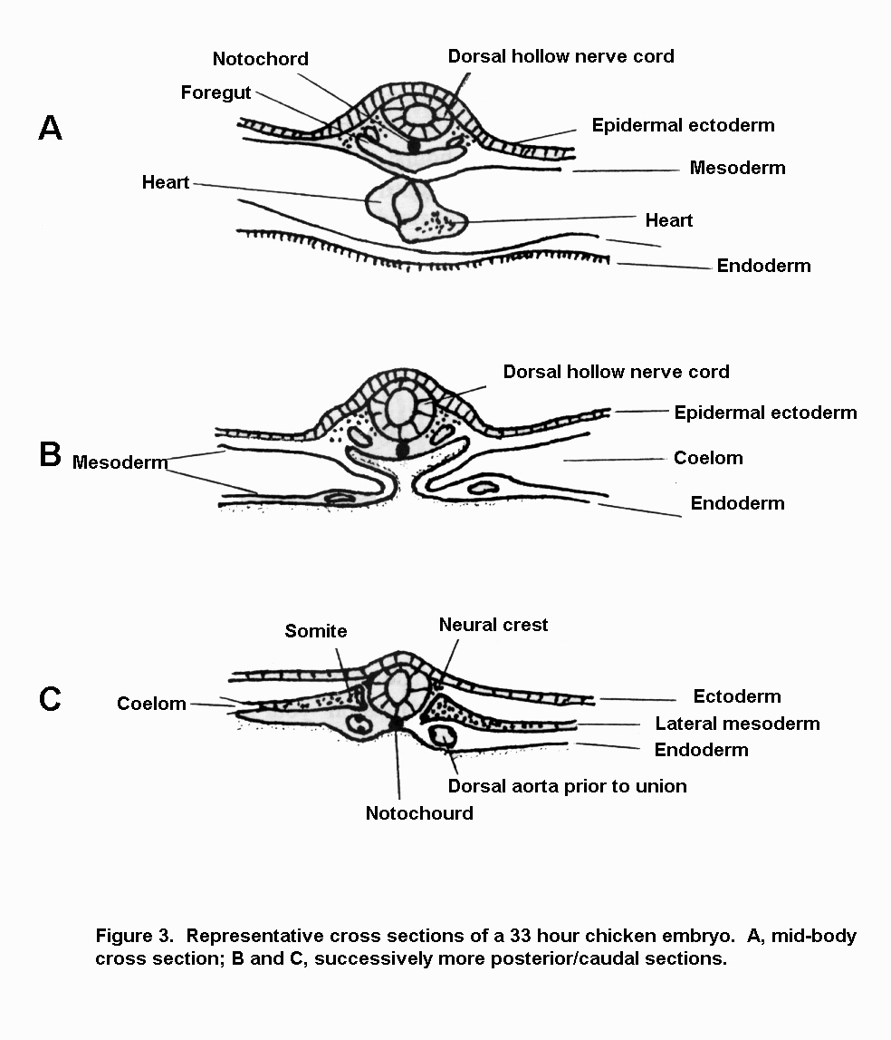

Exercise 4

In the blank space on the next page, provide additional drawings of at least two more sections of the series you are observing.

Draw here:

At this point, the simplest and most fundamental aspects of body organization may be seen in the serial sections. In your drawings, you should have included:

- Dorsal hollow nerve tube running the length of the body.

- A notochord running ventral to the neural tube. It begins at the caudal end of the forebrain and extends the length of the body. Ultimately it will be largely replaced with the bodies of the vertebrae. What remains of it will persist as the nucleus pulposis of the intervertebral discs.

- A dorsal aorta (of if an early specimen, the still paired dorsal aortae) running just ventral and a bit to the left side of the notochord.

- A gut running just ventral to the aorta.

- The coelom surrounding the gut and heart.

- Bilateral lateral mesoderm that has split into the two boundaries of the coelom.

- Surface ectoderm covering the surface of the body.

Items 1-7 are all trans-segmental structures. They extend, uninterrupted, along the longitudinal length of the embryo. Items 8-11 are segmental structures, with one pair for each body segment.

- Somites placed just lateral to the neural tube and notochord.

- Intermediate mesoderm just lateral to the somites.

- Segmental arteries branching off of the dorsal aorta. (They may still be difficult to see at this stage.)

- Segmental nerves from the cells of the neural tube and neural crest (itself segmentally arranged in the embryo, at least at first). (These too may be difficult to see.)

48 Hour Chicken Embryo, Whole Mount

Between the 33 and 48 hour stages, there has been a marked increase in the complexity of the head. Somewhat before the 48 hour mark, the embryo has begun to go through a torsional movement causing the left side of the body to lie on the yolk. This means you will have to take care in orienting yourself and determining what is dorsal and what is ventral as you proceed through the lab. At the same time, due to the development of the very large brain, the head has begun to flex significantly. The bottom line is that the head flexes so much that it comes to lie under the anterior end of the postcranial region of the embryo. This means that when you look at serial sections of the postcranial portion of the body, you will see the head underneath it and upside-down.
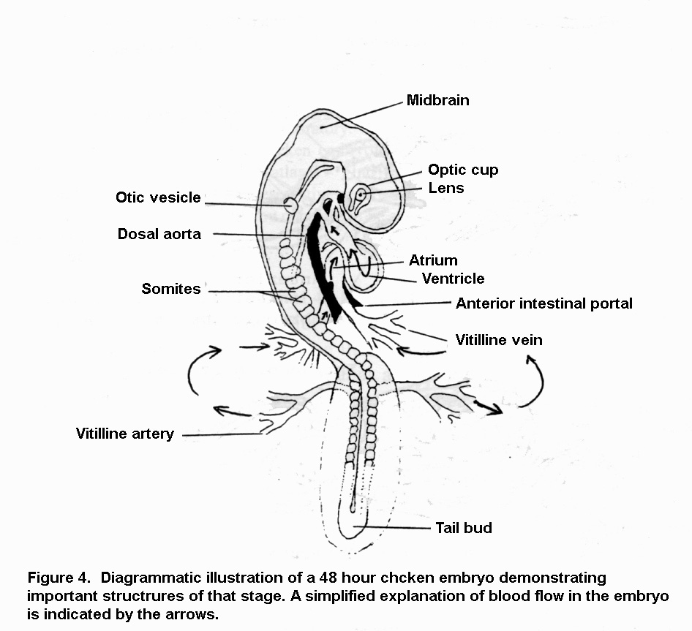

Exercise 5

Using Figure 4 and figure 11.24 from your lab manual/atlas for orientation, examine the 48 hour embryo. Especially, at lower power, the torsion of the body axis and the flexure of the head should be particularly obvious. Also, take note of the now relatively large heart bulging out to the right. Identify: somites, region of the brain, heart, the otic vesicle (future ear), optic cup (future eye), the vitilline vein (from the egg shell to the chicken for oxygen supply), and the vitilline artery ( sending blood away from the heart and body to the egg shell for dumping CO₂ and other wastes.).

48 Hour Chicken Embryo, Serial Sections

Depending on which set of developmental slides you’re using, it could be that there may be more than one slide used to contain the entire series of 48 hour embryo. Some representative sections have been (very) diagrammatically illustrated for you. Figures 11.24K-R from your atlas are similar. Each image notes certain structures, but do remember the need to look at a variety of sections. Be sure to think about whether the structure you’re examining is segmental or trans-segmental. Wherever possible, try to follow a structure as far as you can through the length of the body. (Don’t worry about the head just yet, we’ll do that last.)

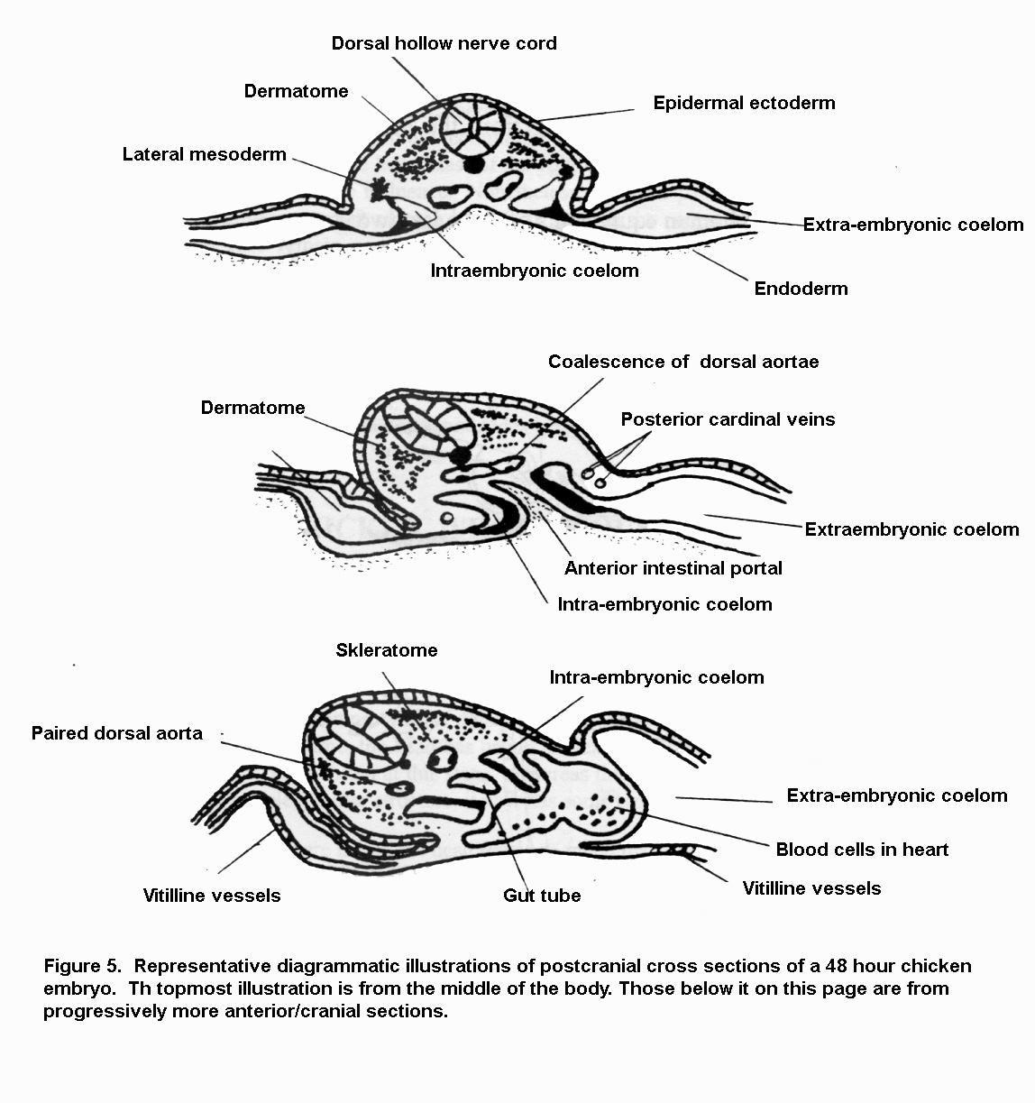
Exercise 6

Begin your examination with a section from the middle of the body (= middle of the series). Start with one that looks like the one at the top of Figure 5 on the previous page. Once you’re comfortable with the spatial arrangement of the structures, move forward and trace as many structures as possible. Be sure to locate: neural tube, somites, notochord, dorsal aorta, coelom, and the gut. Attempt to identify segmental arteries and segmental nerves connecting to the dorsal aorta and spinal cord. As you move forward identify the developing heart. You ought to be able to see red blood cells in the lumen of the heart. Attempt to identify the posterior cardinal veins. They are part of the embryological venous network that dumps into the embryo’s heart.

Which of the structures that you’ve identified are segmental, and which trans-segmental? What are the germ layer origins of these structures?

Draw examples of your 48 hour sections in the space provided below.

72 Hour Chicken Embryo, Whole Mount

By 72 hours, the torsion you began to see in the 48 hour embryo has proceeded about two-thirds the way down the length of the body. There are more somites now; probably as many as 35 if you count carefully. The head is flexed even more, with the tip of the nose/beak almost touching the heart. To facilitate examination of the whole mount at this stage, the circulatory system is often injected with India ink.

At the 72 hour stage, you can see major diverticula (outgrowths) of the endodermally derived gut. Endodermally derived structures of the body proper include: lung buds, part of the liver, possibly the dorsal part of the pancreas, the cloaca, and part of the allantois (an extra-embryonic membrane responsible for – among other things – waste removal and storage.

Exercise 7

The theme of germ layer origin is obviously an important one in this course. Thus, examination of the 72 hour embryo will be organized around groups of similar germ layers derivatives. Fiures 11.27 and 11.28 from your laboratory manual will be of use here.

Exercise 7A – Endodermal Derivatives

Although we are not concerned with the details of the head yet, note that by this stage the mouth is open. At 48 hours, the mouth was not yet open, and the foregut ended anteriorly in an oropharyngeal plate. In the region of the foregut, the liver diverticulum has developed in the ventral mesentery. The foregut will become the stomach and part of the duodenum. The lung bud has also developed. Think of where your lungs connect to the gut tube and you won’t be surprise to learn that the lung buds are connected to the region we now call the esophagus. The tail bud is also now well developed. The under-turning of this bud helps to define the hindgut. The hindgut will be expanded at the anus as a cloaca (Latin for “sewer”) where it gives rise to the allantoic diverticulum.

We now have three regions to the gut:
- Foregut – includes the pharynx, esophagus, stomach, and first half of the duodenum.
- Midgut
- Hindgut

Exercise 7B – Mesodermal Derivatives

Somites will remain obvious in the 72 hour embryo. By this time their internal organization is well developed. You will observe this in serial sections. Intermediate mesoderm is segmental just like the somites, and is found as a small knot of tissue just lateral to them. The intermediate mesoderm will ultimately give rise to the kidneys. The notochord can be seen running the length of the body. The mesodermally lined coelom has developed to surround the gut, as well as the heart with a pericardial sac. The dorsal and ventral mesenteries have developed to suspend the gut tube within the somatic body tube of the embryo. Attempt to locate the India-ink injected dorsal aorta and follow it forward into the heart.

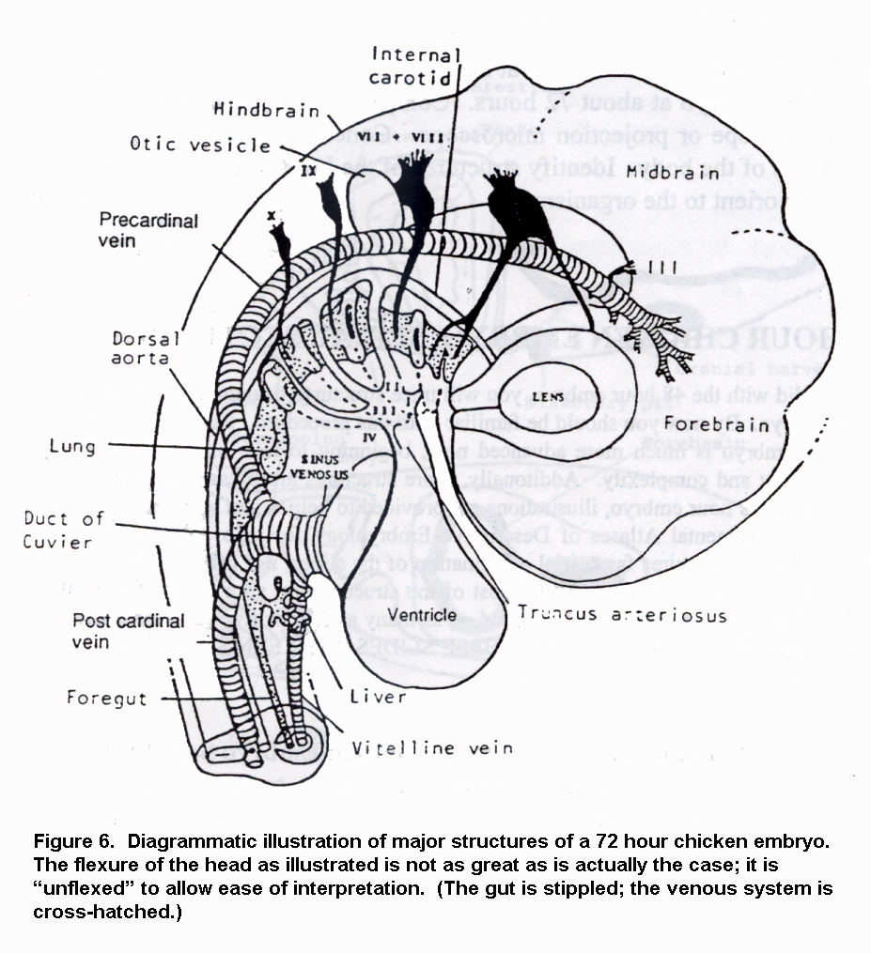

Exercise 7C – Ectodermal Derivatives

In the body, the segmental nerves which will supply sensory (and more) innervation have begun to form. In most whole mounts, these will be difficult to see. However, they may be visible in some. If you can see them, notify your instructor and fellow students. Again, note the position of the neural tube. Remember that the external surface of the developing embryo is ectodermally derived as well.

Exercise 7D – Neural Crest Derivatives

The neural crest is critically important material. The 72 hour stage is about the earliest we can see it in a chicken. Neural crest forms at the junction of the neural and epidermal ectoderm. It is segmentally arranged, and from this position it streams down and laterally into the body to form the basis of a variety of uniquely vertebrate structures. At this point in development, it is giving rise to the dorsal root ganglia of spinal nerves.

72 Hour Chicken Embryo, Serial Sections

As you did with the 48 hour embryo, you will be tracing structures up and down the length of the organism’s body. By now, you should be familiar with this process. The 72 hour embryo is now much more advanced. Not only has it taken on a more adult looking organization, but more structures are developing to confuse you! As with the 48 hour embryo, diagrammatic illustrations are provided here. Use these and the images from your laboratory manual/atlas to help orient yourself. (Notably, it is important that you actually find the structures in your specimens, not just memorize from single images in your text!)

Exercise 8

Trace through the 72 hour embryo (which will be mounted on as many as five slides) and attempt to identify each of the structures labeled in Figure 7 on the next page and Figure 11.37 from the manual. Note that you should trace these structures through a large number of sections to get the feel of their three-dimensional structure and how they vary in morphology in differing regions of the body. Of particular note here are the somites and the neural crest material.

Exercise 8A – Somites

In a favorable section, the internal organization of the somite may now be seen in the 72 hour embryo. Three distinct parts may be recognized. A dorsally placed dermatome will ultimately migrate over the surface of the body, just deep to the ectodermally-derived epidermis and give rise to the segmental dermis. The sklerotome is placed just medially. Its materials will move medially and around the neural tube to form the skeletal elements of the axial skeleton. The myotome will give rise to the epaxial (upper) and hypaxial (lower) components of the body wall musculature.

Exercise 8B – Neural Crest

Attempt to locate and identify the neural crest material expressed as a spinal ganglion just between the dorsal-lateral margin of the neural tube and the dorsal margin of the somite. You will have to scan through a number of sections to find an easily visible example.
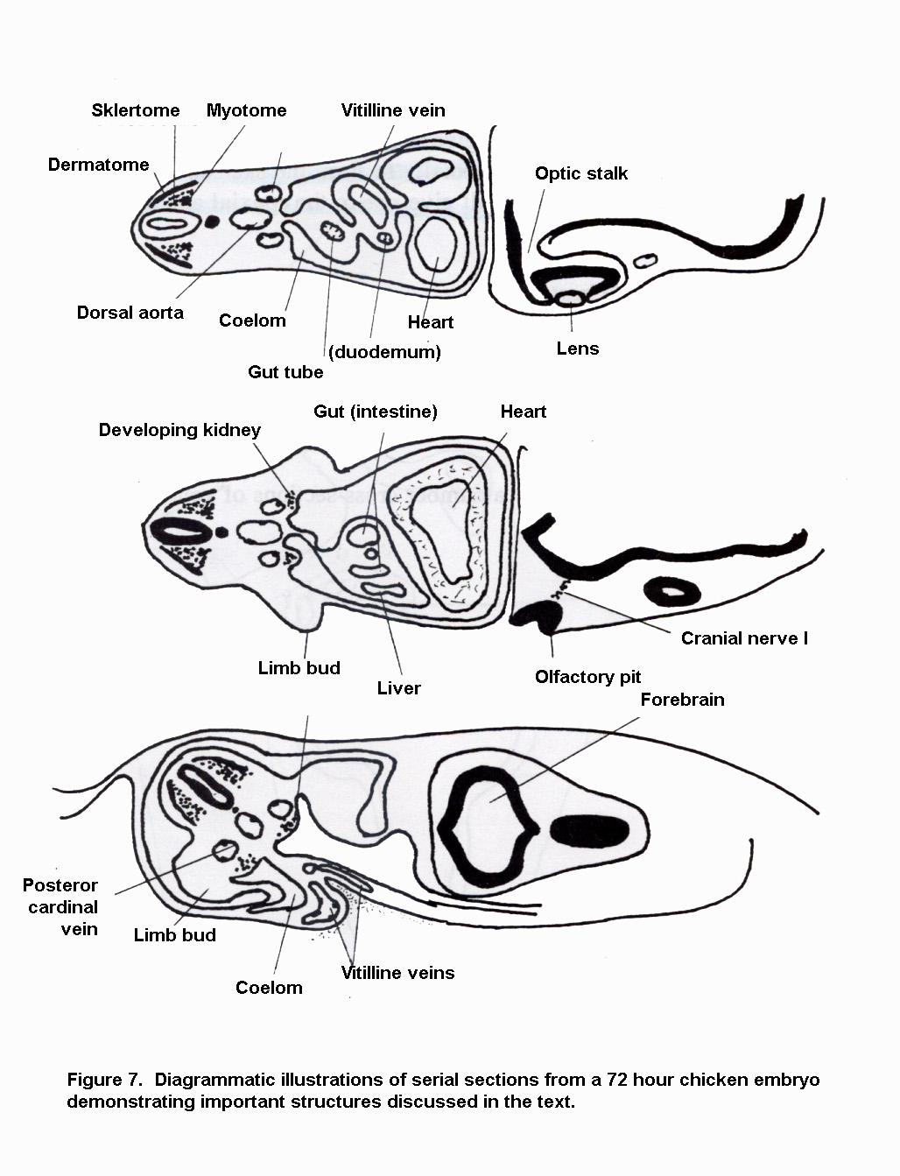
On the next page, draw a number of cross-sections of your own from the 72 hour chicken embryo.

Draw here.

