S. s. SUMIDA
Biology 340
Comparative Embryology

Laboratory Exercise 3
Laboratory Examination of the Chicken Embryo
Part II

Introduction

In the first half of this laboratory exercise, you examined structures of the head only to the degree necessary for orientation. You will now examine the head region in more detail. Now the focus will be on embryos from 33 to 72 hours. 24-hour embryos don’t show enough development to be deeply useful to us here. Further, the majority of your time will be spent with 72-hour embryos as they show most of the features that are of concern in the remainder of this review.

Transsegmental Structures

The dominant transsegmental structures of the head are the dorsal hollow nerve tube and the gut tube, each running approximately parallel to the longitudinal axis of the body. Also in the head region, the circulatory system has some transsegmental structures present.

The Dorsal Hollow Nerve Tube
The dorsal hollow nerve cord is proportionally modified as the brain at the anterior outpost of the body. The brain can be subdivided into a forebrain, midbrain, and hindbrain, referred to as the prosencephalon, mesencephalon, and rhombencephalon respectively. The prosencephalon can be further subdivided into a cranialmost telencephalon and diencephalon. The rhombencephalon is further subdivided into a metencephalon and caudalmost myelencephalon.

Though not continuous an uninterrupted, certain features associated with the brain cannot be said to be segmental either. These are the special sense organs, the nose (olfactory), eyes (optic), and ears (otic). Each is associated with a pair of cranial nerves that are note segmental either: I (olfactory nerve) for the nose, II (optic nerve) for the eyes, and VIII (vestibulocochlear nerve) for the ears. In fact, VIII is primitively associated with VII, a nerve of the segmental gill slits. We will discuss that later.

The Gut Tube
In the head region, the gut tub opens into the body at the mouth. Cranial to the abdominal foregut, in the pharynx region, a series of gill slits or pouches diverge laterally from the gut tube. Although they branch off of a transsegmental structure, these slits/pouches are one of the two primary organizing sets of segmental structures of the body (the other being the somites). Furthermore, they are the dominant setoff segmental structures of the head.

Aortae
The artery emerging from the embryonic heart into the embryo is the ventral aorta. Segmental structures called aortic arches branch off of this transsegmental structure on either side of the pharynx to pass dorsally between the gill slits. Once dorsal to the gill slits, they reattach to the (again) transsegmental dorsal aortae (initially one on each side). The paired dorsal aortae eventually fuse to become a single dorsal aorta that is positioned in the location you would expect it, just ventral to the vertebral axis.

Segmental Structures

Gill Slits (Gill Pouches)
These are often referred to as “pharyngeal pouches”. Recall that in some stage in the course of ontogeny, all chordates possess gill slits. They are a critically important type of segmentation found in the gut tube of the head region, a type of segmentation about which many other systems are organized. Other segmental systems dependant on the position of the embryonic gill slits include the vascular structures, many of the cranial nerves, skeletal components of the splanchnopleure, and musculature of the gut tube.

Visceral Arches
Like fishes, tetrapod amniotes have a skeleton that is associated with the gill slits. While used to support gills in fishes, these skeletal elements known as visceral arches are highly modified in tetrapods. All skeletal elements derived from visceral arches are formed from neural crest.

Aortic Arches
Also as in fishes, tetrapods have blood vessels associate with gill slits. In the embryonic frogs you studies, they were temporarily associated with the external gills. In amniotes, these aortic arches become modified in adults as blood vessels that will serve the head, neck, and cranial part of the torso.

Cranial Nerves Associated with Visceral Arches
Each of the embryonic gill slits, along with the mouth/jaw is associated with a particular pair of cranial nerves. They originate in the dorsal region of the brain and are thus termed dorsal root cranial nerves (even though they eventually emerge from the brain on its ventral undersurface). The include V (trigeminal nerve), VII (facial nerve), IX (glossopharyngeal nerve), and X (vagus nerve). Additionally, XI (accessory nerve) is closely associated with X both morphologically and evolutionarily.

Musculature Associated with the Visceral Arches
As with the skeletal, vascular and nervous structures associated with the gill slits, there is also musculature associated with each one. The musculature of each gill slit is innervated by the associated cranial nerve.

Segmental Structures Not Associated with the Gill Slits

Certain features of the head are segmental but not associated with the gill slits. Instead, they are associated with the other major type of primary segmentation of the developing body, the somites. They are, appropriately, called head somites. Head somites are serial, repeating structures just like those of the body. The one complication is that the otic capsule (the developing ear) is so massive that it crushes some of them out of existence during the course of its own development. This interrupts their otherwise nicely repeating pattern.

Those head somites that are left are generically termed pre-otic somites and postotic somites, referring to those cranial and caudal to the otic capsule respectively. The pre-otic somites will give rise to the muscles that move the eyeballs about, the “extraoccular muscles”. These muscles will be innervated by cranial nerves III (occulomotor nerve), IV (trochlear nerve), and VI (abducens nerve). The postotic somites are precursors of musculature that will migrate to a position ventral to the gut tube and associated gill slits. In amniotes, this will become predominantly tongue musculature and it is innervated by XII (hypoglossal nerve). Cranial nerves emerge from the ventral underside of the brain like the others, but they originate somewhat more ventrally in the brain proper. Thus, they are referred to as ventral root cranial nerves.

So, with the exception of the relatively weird special sense nerves I and II, V, VII/VIII, IX, and X/XI are dorsal root cranial nerves, whereas III, IV, VI, and XII are ventral root cranial nerves.

Torsion and the Developing Embryo

One of the most confusing aspects of the examination of the developing chicken embryo is the fact that the embryo curls up on itself. Recall that this is due in large part to the fact that the brain and head develop so quickly relative to the rest of the body. Thus, the head comes to be bent around and under the body. Ultimately it comes very close to touching the developing heart! You must keep this in mind as you examine the developing embryos. It is impossible to position all of the slices of the prepared embryo such that they always pass perpendicular to the long axis of the body, or conveniently on your prepared slide. You will often be looking at sections that are curled up such that both cranial and post cranial structures can be seen in one slice. This curvature becomes more pronounced as the embryo gets older. For example, recall that Figure 6 is highly diagrammatic and even though it does show a flexed embryo, it does not even show the actual degree to which bending actually takes place. Be sure to use your laboratory manual/atlas to help in this regard. It often accompanies images with a thumbnail image so you can see the origin of the slice in the embryo and orient it relative to the curved embryo.

Exercise 9

Recall that the whole mount is a three-dimensionally thick structure. Some of the features describe here will only be visible with focusing up and down through a number of levels (focal planes) in the embryo.

Refer back to 33-hour whole mount, Figure 2, and Figures 11.6 and 11.7 from your laboratory manual/atlas. Attempt to identify the basic subdivisions of the brain. The prosencephalon (forebrain) has begun to subdivide into the more rostral (“nose-ward”) telencephalon and more caudal diencephalon. The optic vesicles (structures of the eyes) are developing bilaterally from the diencephalon. The mesencephalon will remain undivided. Depending on your specimen, the rhombencephalon might be showing the beginnings of its subdivision into the more rostral metencephalon and more caudal myelencephalon by now.

With careful focusing, attempt to find the cranialmost extent of the notochord. Just cranial to the termination of the notochord is the infundibulum. The infundibulum buds out of the ventral aspect of the diencephalon. The infundibulum also lies just cranial to the oropharyngeal membrane. The infundibulum will ultimately become part of the pituitary gland.

Exercise 10

Refer back to 48-hour whole mount, Figure 3, and Figure 11.20 from your laboratory manual/atlas. Recall that because of the growth of the brain and the macrolecithal condition of the chicken egg, the embryo undergoes considerable torsion and cranial flexion between 33 and 48 hour stages. The head is now “hook-shaped” with the right side of the head facing up at you in typical slide mounts.

Find the developing eye and lens. The otic vesicle (ear) is now visible. Two or three (of the ultimately six) aortic arches should also be visible at this time. Identify them and their position relative to the gill slits and the developing heart.

Rathke’s pouch is an invagination of the ectoderm of the oral region (the roof of the mouth). It is also called the hypophyseal pouch. It will grow up toward the infundibulum and contribute to the development of the pituitary gland. So, if you can find the infundibulum, you ought to be able to find Rathke’s pouch.

As you did with the 33 hour whole mount, attempt to identify the five subdivisions of the brain. Again, find the optic cup, the lens, the otic vesicle, as many aortic arches as possible, and the notochord if you can. The anterior cardinal veins lie approximately dorsolateral to the dorsal aortae. Trace these veins from the region of the midbrain to the common cardinal veins that dump into the heart.

Exercise 11

This next exercise will be the most involved and time-consuming of the period. (Be patient!) You must be able to mentally move between the three-dimensional organism and a series of two-dimensional slices/sections. For this reason, we will not differentiate whole mount and serial exercises for exercise 10 with the 72-hour embryo. It is suggested that you orient with the whole mount first, and then move to serial sections. If groups can cooperate to keep one whole mount on a scope while others scan serial sections, it might be a useful cooperation. After you have examined the serial sections, return to the whole mount to be sure you can mentally organize all of this information three-dimensionally.

There is a series of twelve illustrations following the text here. These are strategically selected sections intended to aid you in identifying structures of the 72-hour chicken embryo. The sections are ordered as if the sectioning process began at the top of Figure 6 and carried on caudally through the embryo. These images are by no means representative of the entire embryo (nor what you are responsible on for quizzes!). Be sure to consult your laboratory manual/atlas for the full detail of what can be seen in serial sections.

Exercise 11A – 72-hour Chicken Embryo; Developing Mouth and Pharyngeal Pouches

The first thing you should do is find each of the successive pouches that are budding off of the pharynx. With the help of figure 11.38F-H of your laboratory manual you will find they are from cranial to caudal: the mouth (mandibular pouch), the hyoid pouch, the first undifferentiated branchial pouch, the second branchial pouch, and so on. Usually, not more than four are visible by this stage. (But you may be lucky – of so, notify the laboratory instructor and fellow students.) Base your identification on whether the pouch is open to the outside of the body or not. The mouth will be open. The hyoid pouch and first branchial pouch will probably be open, forming a true gill slit to the outside. Accurate identification of the gill slits/pouches is very important. Remember, they are the primary organizing type of segmentation of the head. When you are confident that you can make an accurate identification of each slit/pouch, you are ready to continue.

The developing mouth is called the stomadeum. When you get to the stomadeum, note its similarity to the other gill arches. The mouth, jaws, and associated nerves plus blood vessels evolved from a generalized visceral arch (much like those more caudally placed) in more primitive jawless vertebrates. (Note, jawlessness is the primitive condition for vertebrates.)

Exercise 11B – 72-hour Chicken Embryo; Dorsal Root Cranial Nerves

You should now locate each of the dorsal root cranial nerves (V, VII, IX, X) and trace them into the region of the pharynx. By this stage, each should have formed a nerve which passes into the tissue caudal to a gill slit/pouch. Remember, the mouth is a highly modified gill slit.

In each case, the nerve which enters a specific gill pouch (visceral arch) will supply the musculature that develops there fro the mesoderm surrounding the gut. Each of these nerves is called a post-trematic nerve because it enters the tissue caudal (behind/post) to the designated gill slit/pouch. Additionally, each of the dorsal root cranial nerves has a pretrematic branch that passes over and in front of the same gill slit. Pretrematic nerves do not carry motor fibers; they are strictly sensory (both somatic sensory and visceral sensory), whereas post-trematic nerves carry both motor and sensory fibers to the musculature of the visceral arches.

Cranial Nerve V; Trigeminal Nerve (Laboratory Manual Figure 11.38G-H)
The ganglion of V is pre-otic (in front of the developing otic capsule), Three terminal nerves can be identified (thus the ‘tri’ in trigeminal): V₁, the ophthalmic nerve which passes dorsal to the eye; V₂, the maxillary nerve which passes into the tissue cranial to the mouth; and V₃, the mandibular nerve which passes into the tissue caudal to the mouth. V₂, may be identified as a pretrematic nerve (sensory to the area above the mouth/beak), whereas V₃ is post-trematic, providing motor innervation to muscles associated with the mandibular arch. What of V₁? It is in fact pretrematic. The reason for this is because it was originally associated with a primitively more rostral arch in more primitive jawless vertebrates. When the jaws evolved, this pretrematic branch was captured and incorporated (fused) into the trigeminal nerve.

Cranial Nerve VII; Facial Nerve (Laboratory Manual Figure 11.38E)
The ganglion is pre-otic and at this stage a single terminal nerve passes into the tissue caudal to the hyoid pouch (hyoid arch).

Cranial Nerve VIII; Vestibulocochlear Nerve (Laboratory Manual Figure 11.38E)
This nerve is actually morphologically and evolutionarily an especially large branch of VII. It passes to the developing organs of hearing and balance in the otic vesicle. Only the distal portion of the developing nerve will be identifiable as a discreet nerve at this stage. The more proximal portion can’t be distinguished from VII.

Cranial Nerve IX; Glossopharyngeal Nerve (Laboratory Manual Figure 11.38C)
The ganglion is post-otic and a single terminal nerve passes into the tissue caudal to the first undifferentiated branchial pouch.

Cranial Nerve X; Vagus Nerve (Laboratory Manual Figure 11.38F)
The ganglion is post-otic and a terminal nerve passes into the tissue caudal to the second undifferentiated branchial pouch. If the stage of your specimen is sufficiently advanced, a second branch of the vagus nerve might be seen to enter into the tissue of the next more caudal branchial pouch (third pouch). The vagus will also send a branch to the fourth pouch later in development, and ultimately continue far down the gut tube to the terminus of the abdominal midgut.

Exercise 11C – 72-hour Chicken Embryo; Dorsal Aortae, Ventral Aorta, and Aortic Arches

Locate the heart. Now locate the stubby ventral aorta emerging from it. In most cases the ventral aorta may not be distinguishable from the spray of aortic arches (Figures 11.38G-H of your laboratory manual) leaving near the heart. By this stage, the first aortic arch (blood vessel of the mandibular arch, arch of the mouth) has probably already regressed to the point that it is no longer visible. However, you ought to be able to identify arches II, IV, and perhaps even V. (What’s left of the first aortic arch will contribute to a bit of the postnatal maxillary artery.)

Confirm that the second aortic arch is the one that passes to and supplies the hyoid arch. Remember that the facial nerve (cranial nerve VII) is the nerve of the hyoid arch. As such, the second aortic arch should be positioned just posterior and medial to the facial nerve. (See Figure 6 if you need a review.) Similarly, identify aortic arch 3 and verify that it passes to the next arch and lays posteromedial to the glossopharyngeal nerve (IX). A similar pattern should be expressed for aortic arch 4 relative to the vagus nerve (X).

(Note: ultimately, aortic arch 3 will contribute to the carotid circulation, and is thus called the carotid arch. Aortic arch 4 will contribute to the arch of the aorta and is called the aortic arch, or the systemic arch. Arch 5 disappears (like much of 1 did). Aortic arch 6, which isn’t yet visible at this stage will contribute to the pulmonary arteries, and is thus called the pulmonary arch.)

Exercise 11C – 72-hour Chicken Embryo

Find where the aortic arches hook up with the paired dorsal aortae. Trace the dorsal aorta(e) posteriorly until you see it pass into a region that may be more familiar to you. Figures 9.17 and 9.18 of your laboratory manual will be of use to you here.

Exercise 11D – 72-hour Chicken Embryo; Venous Structures

In the 72-hour stage, certain venous structures are developed well enough to be of mention. Cardinal veins are the veins that help to return venous blood to the heart of the developing embryo. Anterior cardinal veins drain the head; posterior cardinal veins drain the more caudal body wall. Anterior and posterior cardinals come together as tributaries of the common cardinal veins (sometimes called common cardinal sinuses). These dump into the heart.

With the aid of Figures 11.38I-T, identify the anterior cardinal vein. It lies medial to the ganglia of the developing dorsal root cranial nerves. (In some cases, the anterior cardinal vein may lie lateral to the ganglia of VII and IX; venous structures can be quite variable. Don’t worry, the animal will get itself sorted out eventually.) Also, note that the anterior cardinal vein is positioned dorsal and lateral relative to the dorsal aorta on each side.

Exercise 11E – 72-hour Chicken Embryo; Developing Nose and Eye

Find the olfactory placodes (laboratory manual figure 11.38N) on the lateral surface of the snout and identify the associated cranial nerve I (olfactory nerve). Find the optic cup (laboratory manual figure 11.38L-M) of the developing eye. It is now well developed and the lens vesicle sits in its lateral margin. The cleft in the ventral margin of the developing cup is easily visible in this stage.

Figures

There is a series of twelve illustrations following the text here. Recall that these are strategically selected sections intended to aid you in identifying structures of the 72-hour chicken embryo. The sections are ordered as if the sectioning process began at the top of Figure 6 and carried on caudally through the embryo. These images are by no means representative of the entire embryo, so be sure to consult your laboratory manual/atlas for the full detail of what can be seen in serial sections.

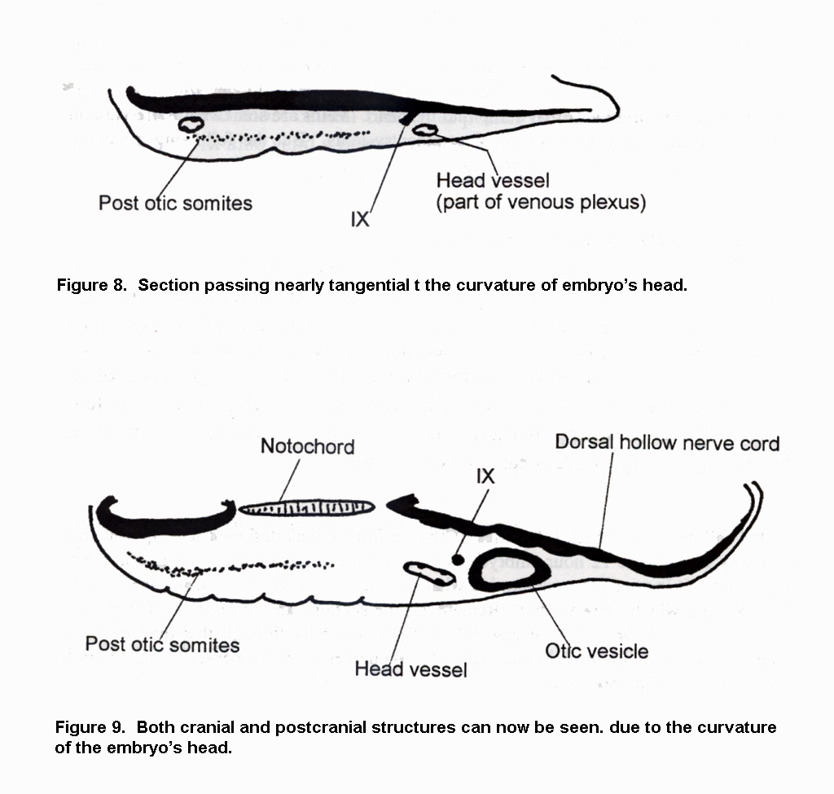

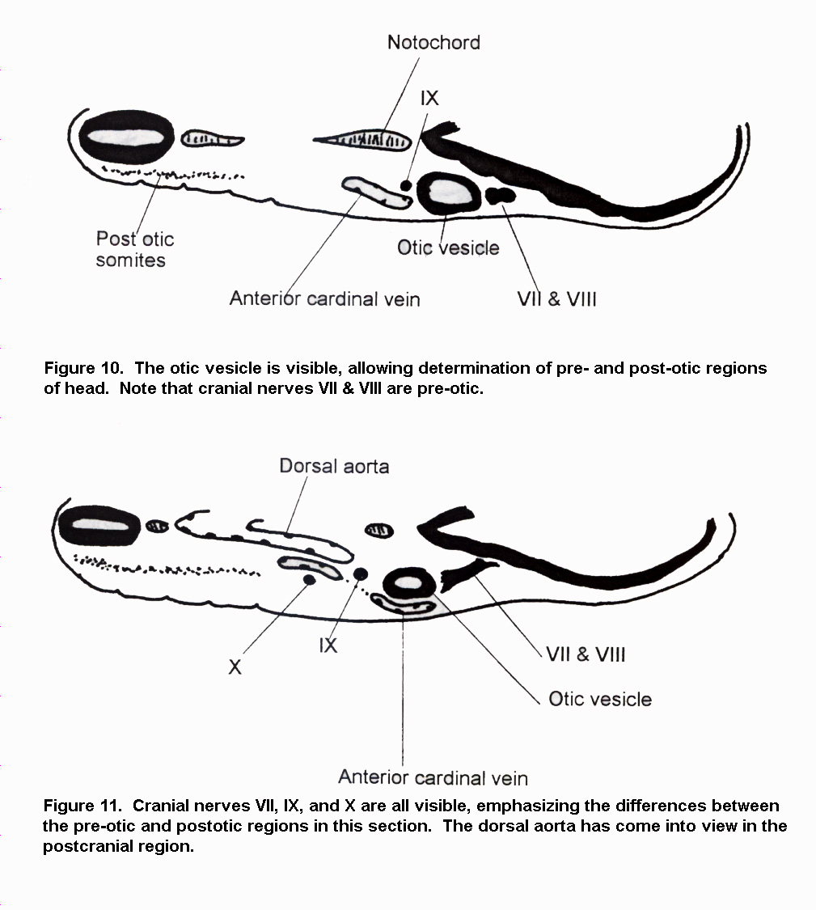

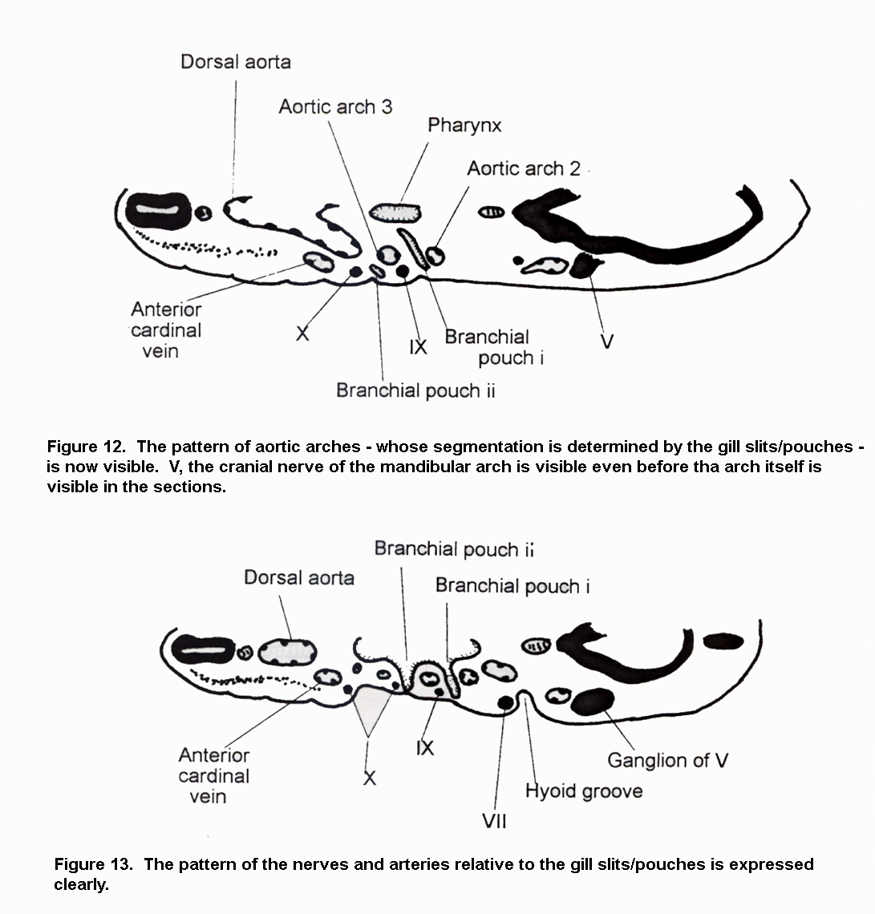

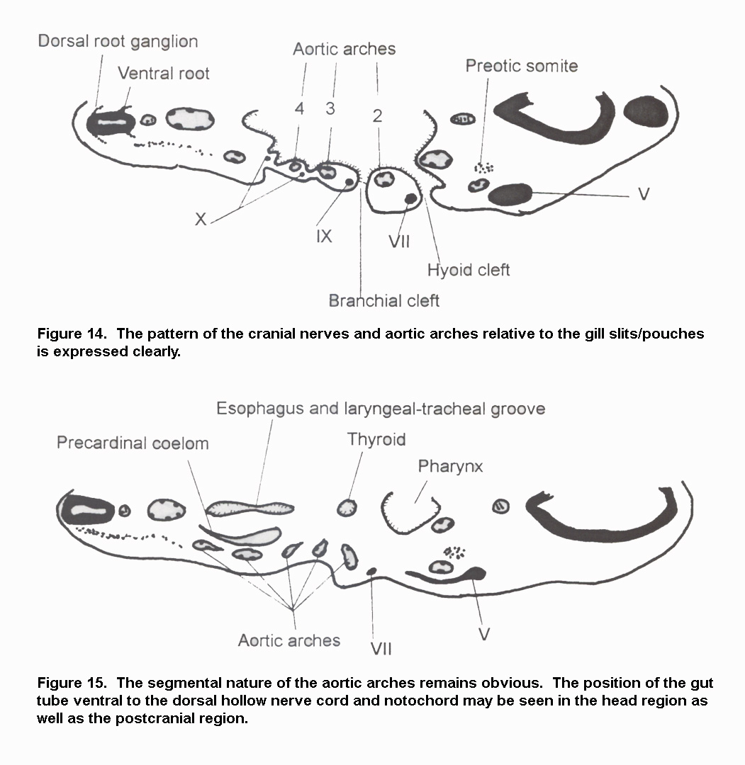

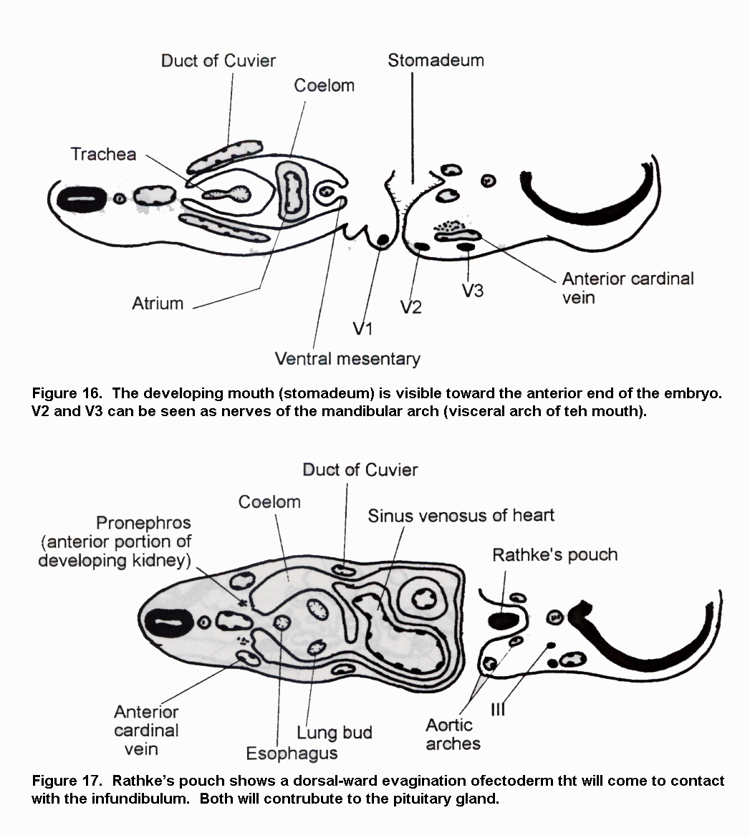

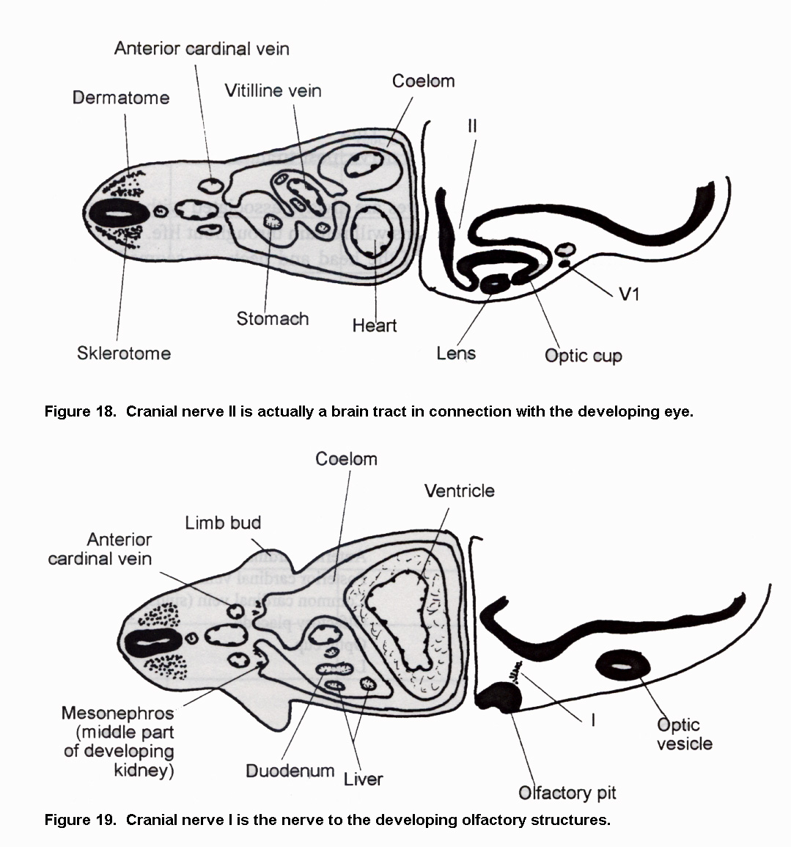

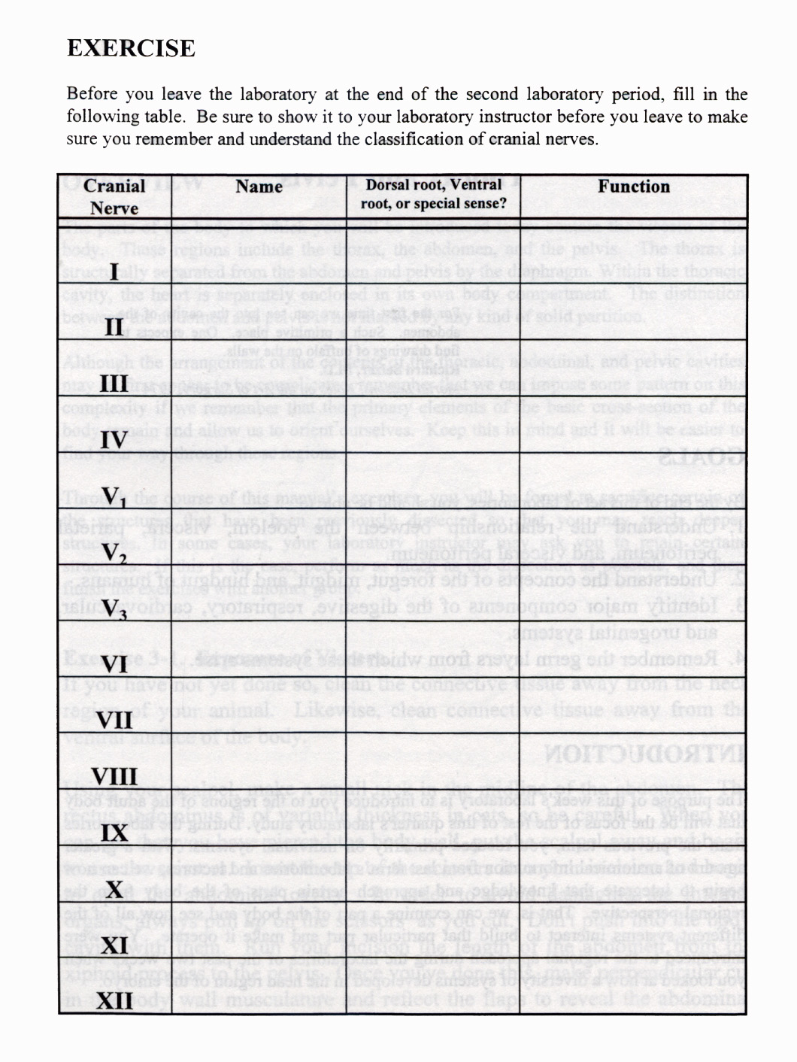
Laboratory 3B APPENDIX 1: Laboratory atlas figures correlated to handout images.

Handout Schoenwolf Manual Figure / Image
Figure

Figure 8

Figure 9

Figure 10

Figure 11

Figure 12

Figure 13 Photo 4.120 - 4.123

Figure 14

Figure 15 Photo 4.118

Figure 16 Photo 4.122

Figure 17 Photo 4.123

Figure 18 Photo 4.124 - 4.126

Figure 19

